MA3923 — Monte Carlo Simulation
Lab 07 — Crude vs Antithetic Monte Carlo Estimation
.Question 1: the crude Monte Carlo estimator
I_M = (1/M)·Σ Y_i, with Y_i = exp(sqrt(U_i)) and U_i drawn straight from Uniform(0,1). For each M I computed the sample mean, sample variance, and the 95% confidence interval I_M ± 1.96·S_M/√M.
M | I_M (estimate) | sample variance | 95% CI | CI width
100 | 1.974507 | 0.201164 | [1.886598, 2.062415] | 0.175817
1000 | 1.986036 | 0.196824 | [1.958538, 2.013533] | 0.054995
10000 | 1.993607 | 0.194875 | [1.984954, 2.002259] | 0.017305
100000 | 1.998062 | 0.194632 | [1.995327, 2.000796] | 0.005469

The exact value, I = 2, sits inside every one of these four intervals. The estimate gets steadily closer to 2 as M grows (off by 0.0255 at M=100, down to just 0.0019 at M=100000), and the CI width shrinks by roughly a factor of √10 each time M is scaled up by 10 exactly the 1/√M rate you'd expect from the standard error formula.
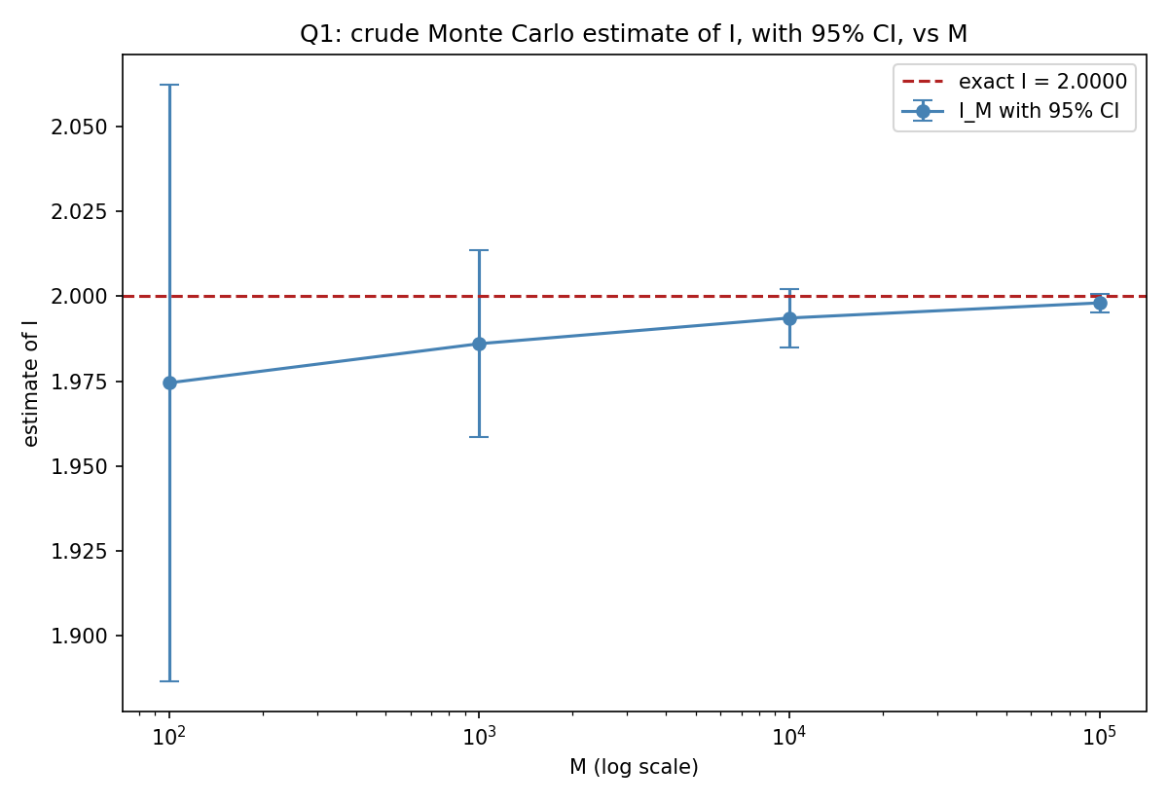
Figure 1.1 - crude estimate of I with 95% CI error bars, across the four values of M.

Question 2: the antithetic-variates estimator
I_hat_M = (1/M)·Σ Y_hat_i, with Y_hat_i = (exp(sqrt(U_i)) + exp(sqrt(1−U_i)))/2. Each Y_hat_i already combines a value at U_i with a value at its antithetic partner 1−U_i, so M of these paired values use 2M evaluations of exp(sqrt(·)) in total - twice the raw function calls of a crude estimator with the same M. That's exactly why the lab asks for M = 50, 100, 500, 1000, 5000, 10000, 50000, 100000: each of these matches the computational cost of a crude run at 2M, setting up a fair comparison in Question 3.
M | I_hat_M | sample variance | 95% CI | CI width
50 | 2.001658 | 0.001102 | [1.992458, 2.010858] | 0.018399
100 | 2.000136 | 0.001161 | [1.993458, 2.006815] | 0.013357
500 | 2.001451 | 0.001009 | [1.998666, 2.004236] | 0.005570
1000 | 2.000609 | 0.001101 | [1.998553, 2.002666] | 0.004113
5000 | 2.000302 | 0.001023 | [1.999415, 2.001188] | 0.001773
10000 | 2.000013 | 0.001071 | [1.999371, 2.000654] | 0.001283
50000 | 1.999826 | 0.001083 | [1.999538, 2.000115] | 0.000577
100000 | 1.999997 | 0.001074 | [1.999794, 2.000200] | 0.000406

Every one of these eight intervals contains 2 as well, and the estimates are noticeably closer to 2 than the crude ones were at comparable M. even at M=50 the antithetic estimate is off by only 0.0017, better than the crude estimator managed at M=100000. The sample variance here is also worth noticing: it sits around 0.001 across the board, versus roughly 0.195 for the crude Y_i in Question 1 about 180 times smaller. That's the antithetic trick doing its job: exp(sqrt(u)) is a monotonically increasing function of u, so U and 1−U pull the paired average toward the middle, cancelling out a large share of the variability that a single draw would have on its own.
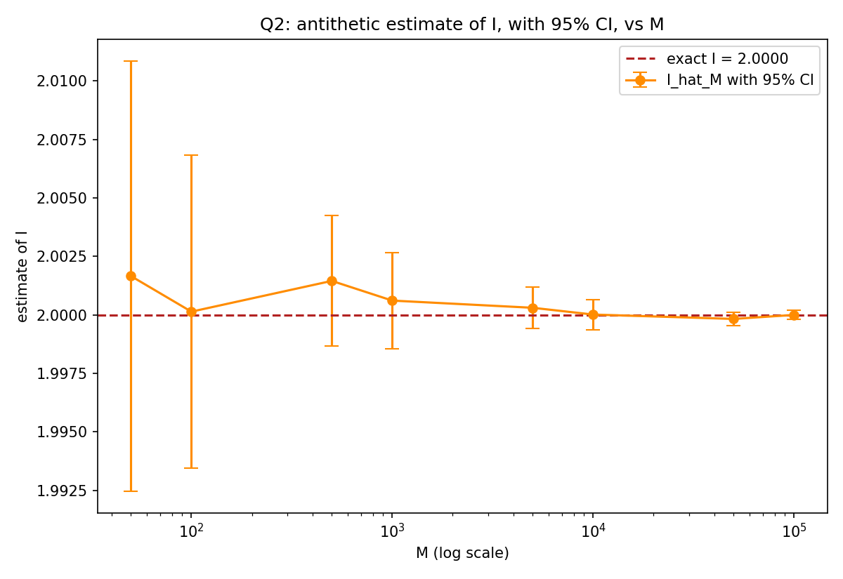
Figure 2.1 - antithetic estimate of I with 95% CI error bars, across the eight values of M.

Question 3: comparing the two methods at matched cost
Matching computational budget (total evaluations of exp(sqrt(·))) rather than just matching M is what makes this comparison fair: crude M=100 and antithetic M=50 both cost 100 evaluations; crude M=1000 and antithetic M=500 both cost 1000; and so on.
budget | crude I_M | crude CI | crude width | antithetic I_M | antithetic CI | antithetic width | width ratio
100 | 1.974507 | [1.8866,2.0624] | 0.175817 | 2.001658 | [1.9925,2.0109] | 0.018399 | 9.56
1000 | 1.986036 | [1.9585,2.0135] | 0.054995 | 2.001451 | [1.9987,2.0042] | 0.005570 | 9.87
10000 | 1.993607 | [1.9850,2.0023] | 0.017305 | 2.000302 | [1.9994,2.0012] | 0.001773 | 9.76
100000 | 1.998062 | [1.9953,2.0008] | 0.005469 | 1.999826 | [1.9995,2.0001] | 0.000577 | 9.48

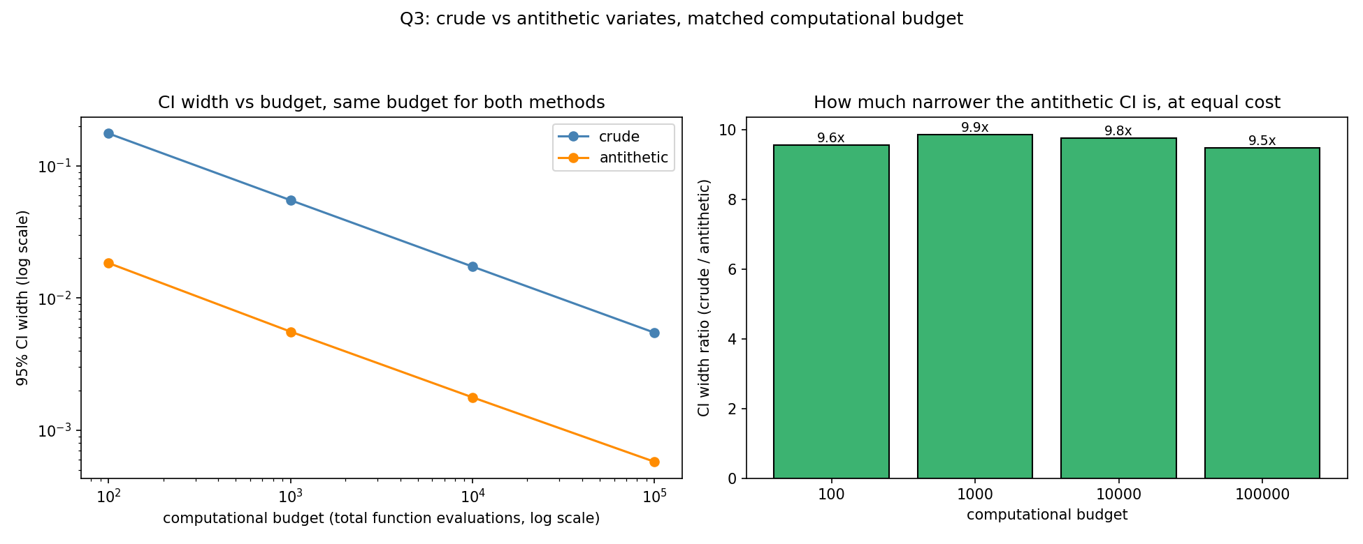
Figure 3.1 - left: CI width vs budget for both methods, log-log scale; right: how many times narrower the antithetic CI is, at matched cost.
How the estimates compare with the exact value
At every budget level, the antithetic estimate is closer to the true value I=2 than the crude estimate at the same cost at budget 10000, for instance, the crude estimator is off by 0.0064 while the antithetic estimator is off by only 0.0003, roughly 20 times closer. That gap is consistent with the CI-width ratio in the table, which sits remarkably steady at around 9.5 to 9.9 across all four budget levels antithetic variates aren't just helping a little here, they're giving a confidence interval routinely about a tenth the width of the crude one, for exactly the same number of function evaluations.
Observations
- Both methods converge to the exact value I=2 at the same underlying rate — the two lines in Figure 3.1 (left) are parallel on a log-log plot, both dropping as 1/√(budget). Antithetic variates don't change the convergence rate; they shrink the constant in front of it.
- The width ratio staying close to 9.5-9.9x across every budget level (rather than drifting up or down) is a good sign that the variance reduction here is a genuine structural effect of the pairing, not a fluke tied to one particular sample size.
- The reason antithetic variates work so well specifically for this integrand is that exp(sqrt(u)) is monotonic on (0,1). Pairing u with 1−u induces negative correlation between exp(sqrt(U)) and exp(sqrt(1−U)) whenever the underlying function is monotonic, and it's exactly that negative correlation that cancels variance when the two are averaged. For a non-monotonic integrand the benefit can be much smaller, or in principle even negative — the technique's effectiveness is a property of the specific function being integrated, not a free win in every problem.
- Practically, this means that for the same computational budget, the antithetic method gets you roughly a tenth the uncertainty here — or, put the other way, you'd need on the order of 90-100 times as many crude samples to match the antithetic estimator's precision at a given M.

